**Steps involved in restarting the service:**

1. Open services either from start option or by cmd prompt

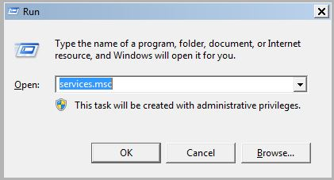

1. In Services, go to Actions -> Connect to another computer

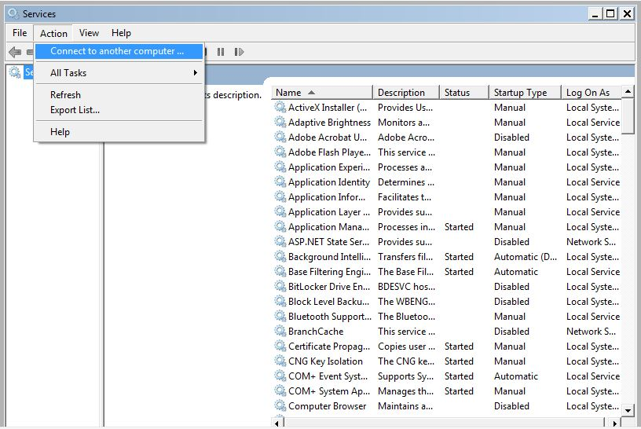

1. Enter the domain name which you want to restart

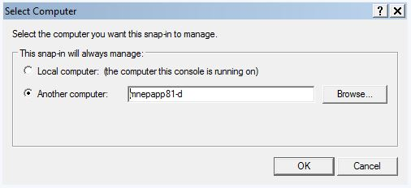

1. Search for theJboss xPression1 Server in the services tab and select for restart

